Research Paper: Data-Driven Profitability and Supply Chain Diagnostics for Nassau Candy Distributor
Author: Divya Deep Singh
Subject: Advanced Financial Exploratory Data Analysis (EDA) & Product Rationalization
Dataset Reference: Nassau Candy Distributor.csv
1. Abstract
This research paper addresses a foundational operational risk at Nassau Candy Distributor: the reliance on gross sales volume as a proxy for financial health. Utilizing raw transactional order logs from Nassau Candy Distributor.csv spanning 10,194 records, we cleaned, enriched, and mapped order data to geographic production origins to isolate the true drivers of profitability. The analysis reveals an extreme Pareto concentration where 5 chocolate-line items generate 95.06% of the company's gross profit. Conversely, structural inefficiencies were identified in the "Other" division, notably driven by Kazookles, which exhibits a dangerously low gross margin of 7.69%. This paper delivers mathematical frameworks, division benchmarks, cost diagnostics, and strategic portfolio recommendations to move the distributor from reactive, intuition-based decisions to a proactive, maximized margin model.
2. Problem Statement & Objective
For large-scale distributors like Nassau Candy, high-volume products can hide severe operational cost overruns. Some products command high sales visibility but ingest disproportionate manufacturing, logistics, or operational capital, eroding overall corporate health.
Currently, the organization lacks visibility into:
- Which specific product lines deliver the highest real gross margin versus top-line sales.
- The structural margin variations across separate product divisions (Chocolate, Sugar, Other).
- Over-dependency and margin risk concentration within specific product families.
The objective of this research is to apply precise data diagnostics to create a definitive margin leaderboard, identify cost-heavy products for price optimization or discontinuation, and establish a framework for the interactive Streamlit Web Application.
3. Analytical Methodology & KPI Framework
Data Cleaning and Preparation
The dataset Nassau Candy Distributor.csv was subjected to rigorous validation via Python:
- Invalid Record Filtering: Records showing zero or negative sales were removed to isolate valid commercial activity.
- Missing Values Treatment: Null records in critical fields like Units or Gross Profit were dropped.
- Supply Chain Mapping: Products were mapped to their respective factory facilities and geographic coordinates using the following structure:
Division | Product Name | Factory Location | Latitude | Longitude
Chocolate | Wonka Bar (Nutty Crunch, Fudge Mallows, Scrumdiddlyumptious) | Lot's O' Nuts | 32.881893 | -111.768036
Chocolate | Wonka Bar (Milk Chocolate, Triple Dazzle Caramel) | Wicked Choccy's | 32.076176 | -81.088371
Sugar | Laffy Taffy, SweeTARTS, Nerds, Fun Dip, Fizzy Lifting Drinks | Sugar Shack | 48.119140 | -96.181150
Sugar | Everlasting Gobstopper | Secret Factory | 41.446333 | -90.565487
Sugar | Hair Toffee | The Other Factory | 35.117500 | -89.971107
Other | Lickable Wallpaper, Wonka Gum | Secret Factory | 41.446333 | -90.565487
Other | Kazookles | The Other Factory | 35.117500 | -89.971107

Core Mathematical Formulations
The analytical framework relies on three primary corporate KPIs calculated at an item-by-item level:
$$\text{Gross Margin (\%)} = \frac{\text{Gross Profit}}{\text{Sales}} \times 100$$
$$\text{Profit per Unit} = \frac{\text{Gross Profit}}{\text{Units}}$$
$$\text{Profit Contribution (\%)} = \frac{\text{Product Gross Profit}}{\text{Total Corporate Gross Profit}} \times 100$$
4. Empirical Findings & Analysis
Division-Level Performance Metrics
Aggregated corporate tracking from Nassau Candy Distributor.csv shows total corporate sales of $141,783.63 and gross profit of $93,442.80, yielding a healthy baseline corporate gross margin of 65.91%. However, division breakdown tells a highly imbalanced story:

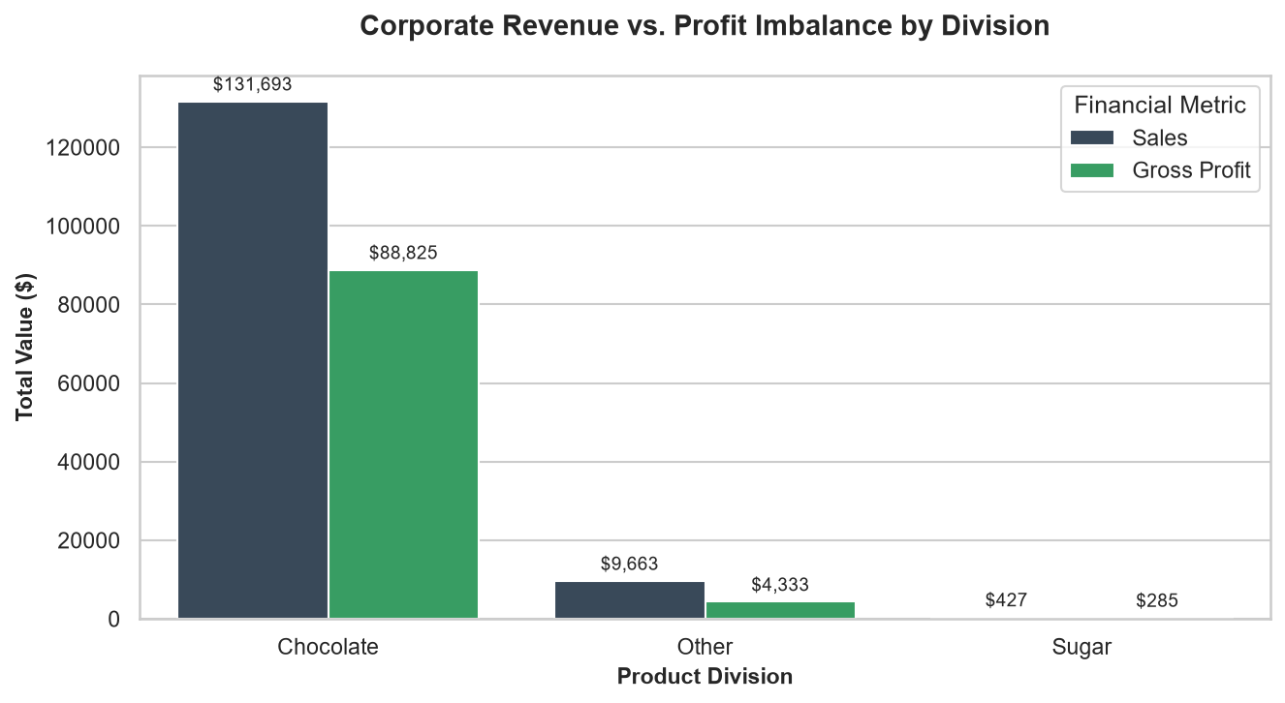
Figure 1:Comparative analysis of top-line sales revenue vs. realized gross profit by product division.

Key Insight: The Chocolate division is the financial engine of Nassau Candy, representing 92.88% of all revenue and 95.06% of total profits. The Other division introduces substantial operational friction, dragging corporate efficiency down with an average gross margin that is over 22 percentage points lower than chocolate.

Product-Level Profitability and Cost Diagnostics
A granular look at individual product profiles isolates the precise operational liabilities and successes:

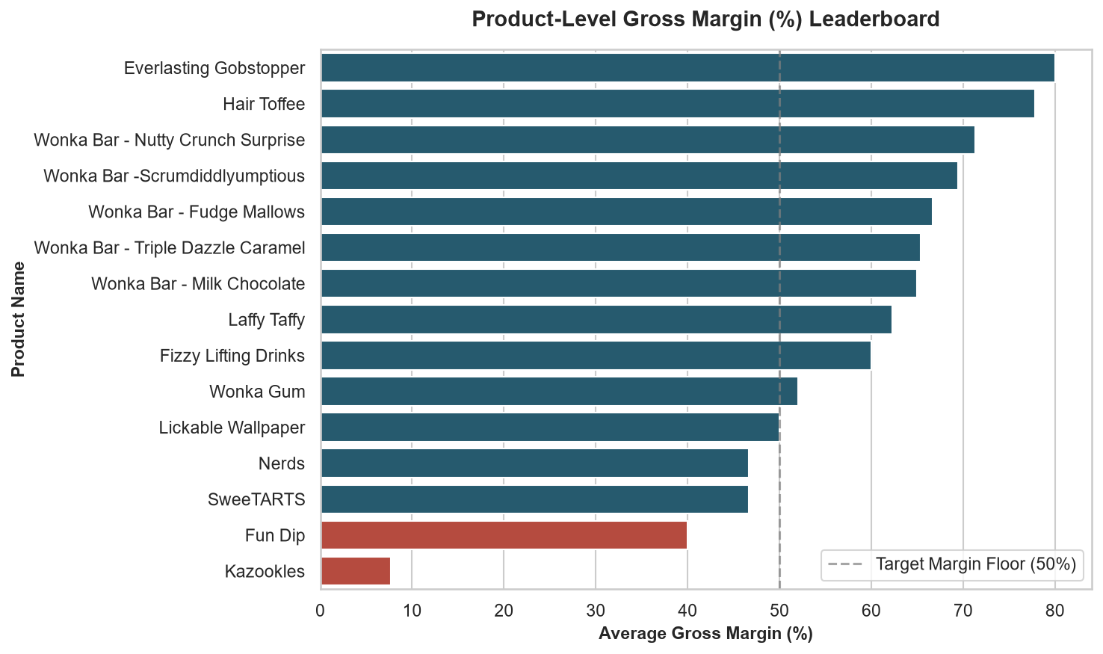
Figure 2:Comprehensive product margin leaderboard highlighting high-efficiency products vs. margin traps.

Profit Concentration (Pareto Analysis)
Sorting all items by cumulative profit contribution proves a critical structural reality: exactly 5 products out of 15 (33.3% of the catalog) generate 95.06% of total gross profit.
This creates an acute over-dependency risk. Nassau Candy's financial survival depends entirely on the continuous manufacturing capacity of two locations: Lot's O' Nuts and Wicked Choccy's. Any regional logistical delay or supply failure at these factories directly threatens 95% of the firm's bottom line.

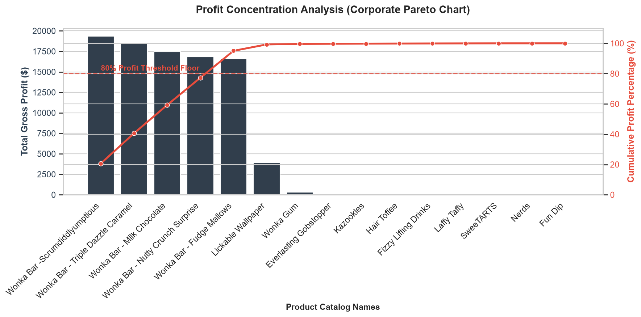
Figure 3:Corporate Pareto chart showcasing the extreme concentration of gross profit within five core product SKUs
5. Strategic Recommendations
- Immediate Price Restructuring for Kazookles:
Manufactured at The Other Factory, Kazookles commands over $1,200 in top-line sales but retains only $92.75 in profit due to an extreme cost profile (92.31% production/logistics cost). Nassau Candy must raise wholesale prices by a minimum of 25% or renegotiate supplier contracts with The Other Factory to adjust the cost base. If negotiations fail, this product should be earmarked for immediate discontinuation.
- Expansion of High-Margin Chocolate SKU lines:
Wonka Bar - Nutty Crunch Surprise demonstrates a stellar 71.35% gross margin. Marketing and promotional allocation should prioritize this product over lower-margin alternatives to shift product mix toward maximum yield.
- Supply Chain Redundancy Planning:
Because the company's financial stability relies heavily on Lot's O' Nuts (Arizona) and Wicked Choccy's (Georgia), an operational backup network must be established to guard against unexpected regional distribution or supply challenges.
